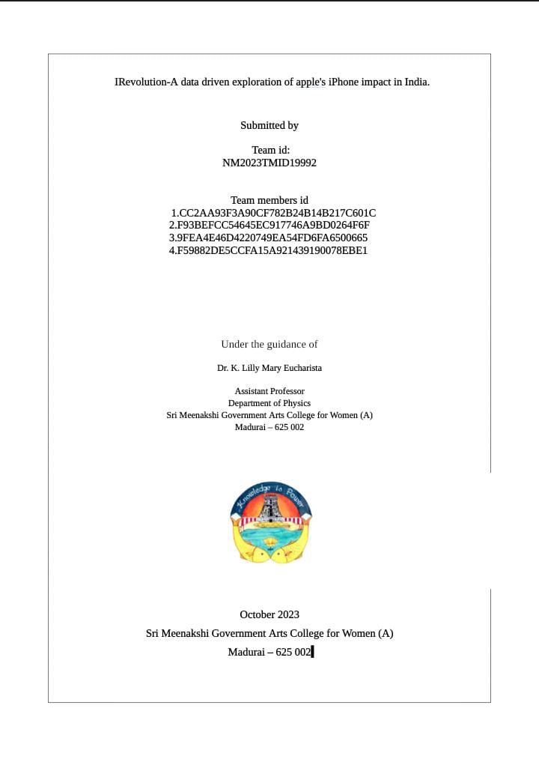

INTRODUCTION:

OVERVIEW:

1)Apple has a special chance to increase its marks share and develop a significant presence in India.

2)Iphones is India will help the company to cut down the cost price and it can save tax on imparting units from different countries.

PURPOSE:

1. Iphone have a major gain in every aspects.
2. The iphone is a smart phone made by Apple that combines a computer, ipad, digital camera and cellular phone into one device with a touchscreen interface.
3. The ‘i’ in Apple devices stands for internet introduced in 1998 with the iMac.

PROPLEM DEFINITION AND DESIGN THINKING:

1)Empathy map

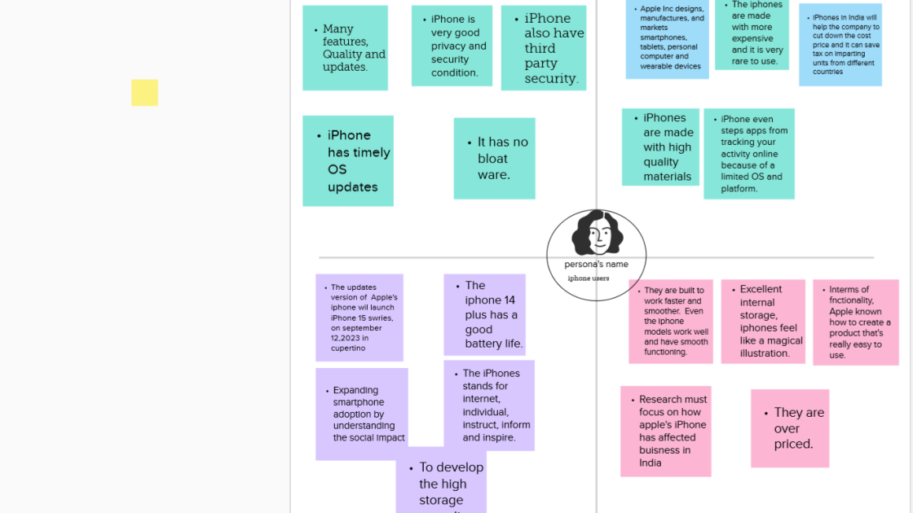

2)Brainstorming map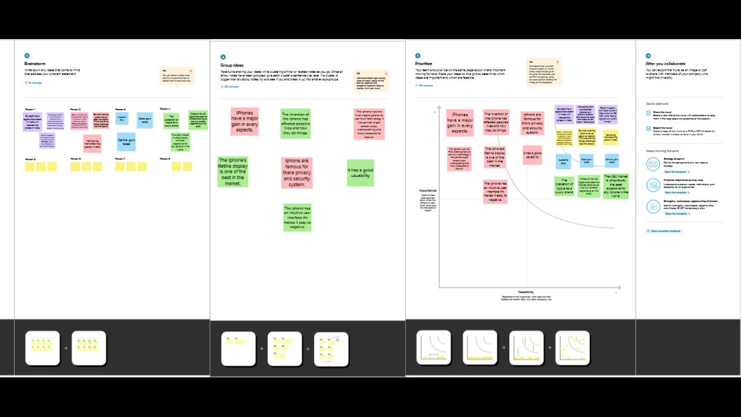

RESULT:

Visualisation screenshot:

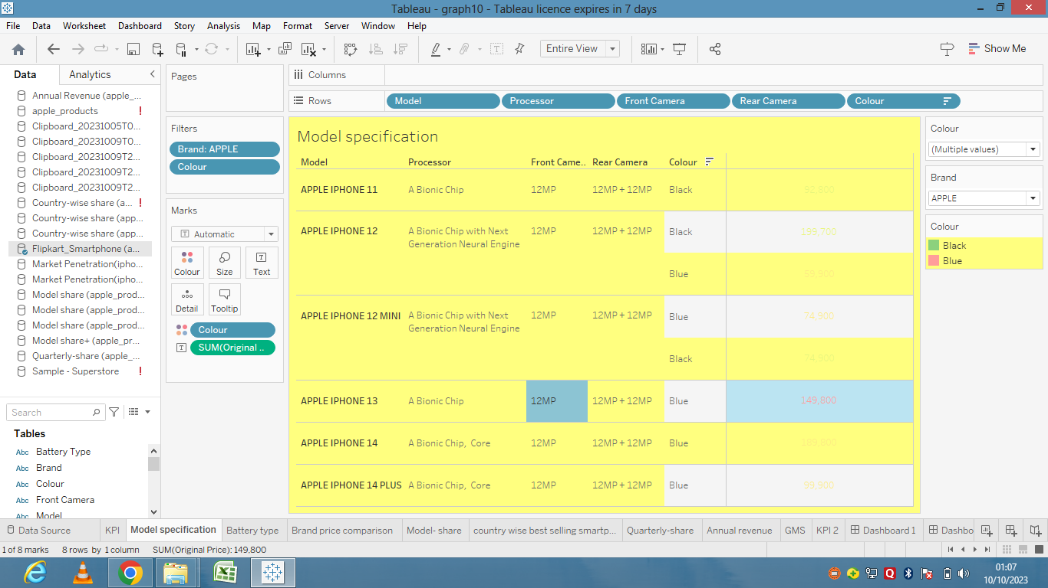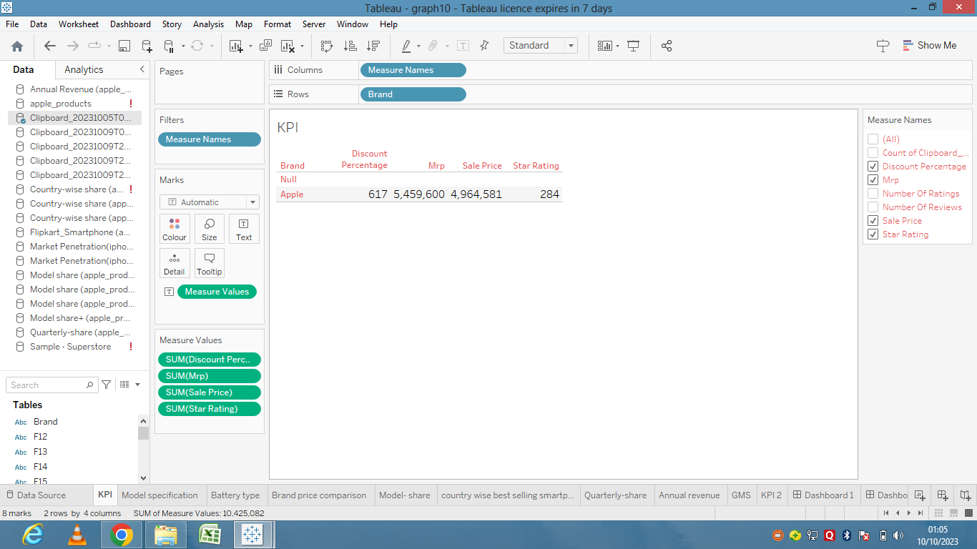

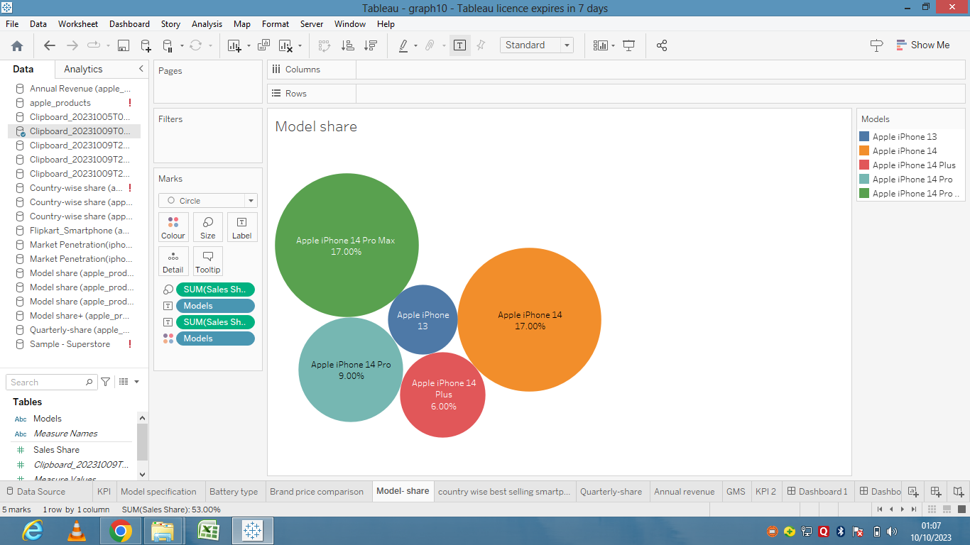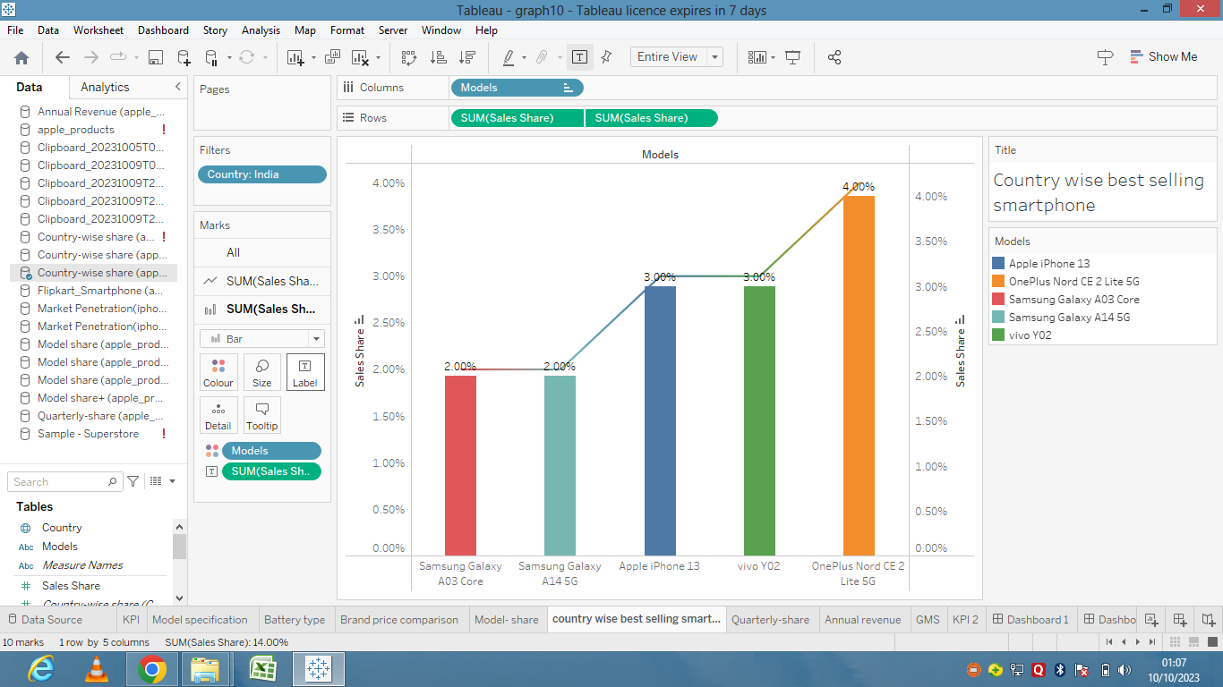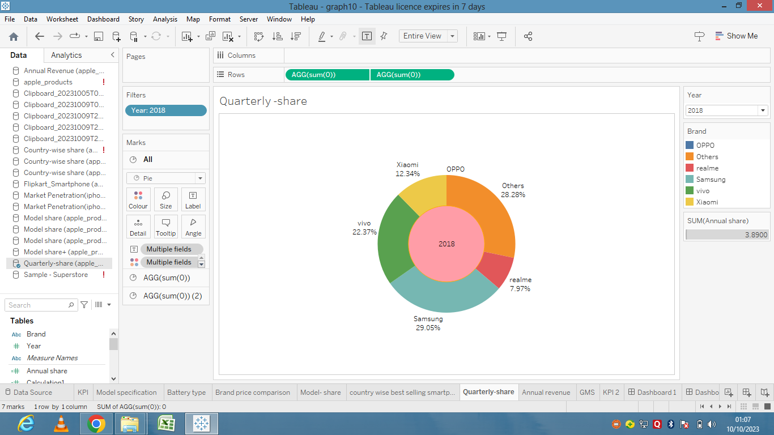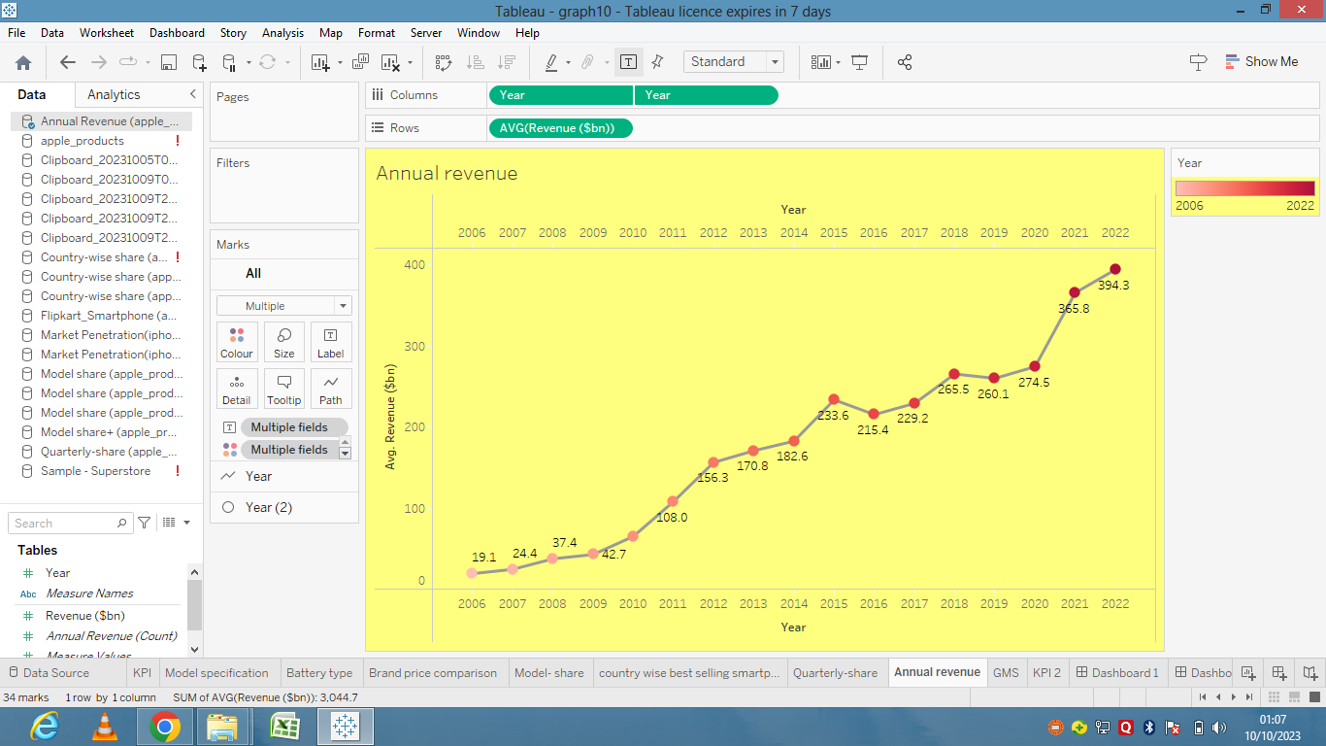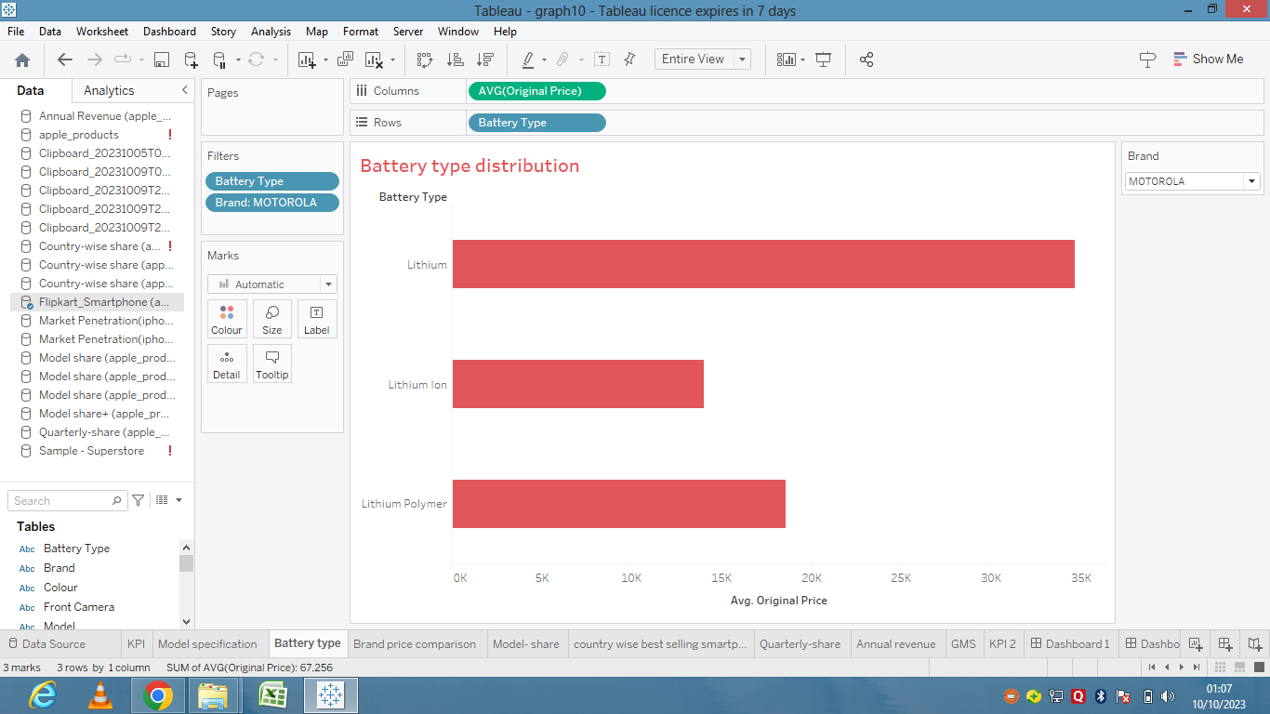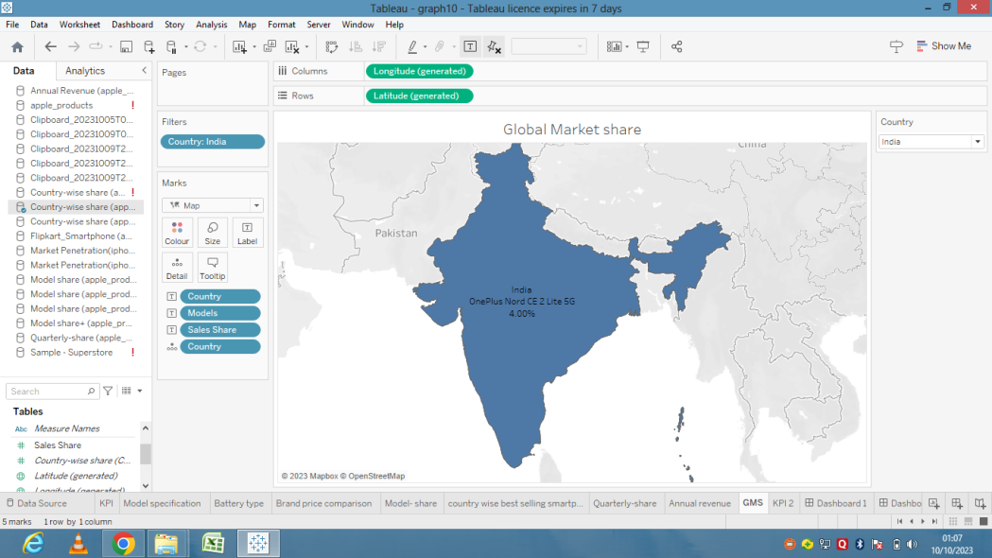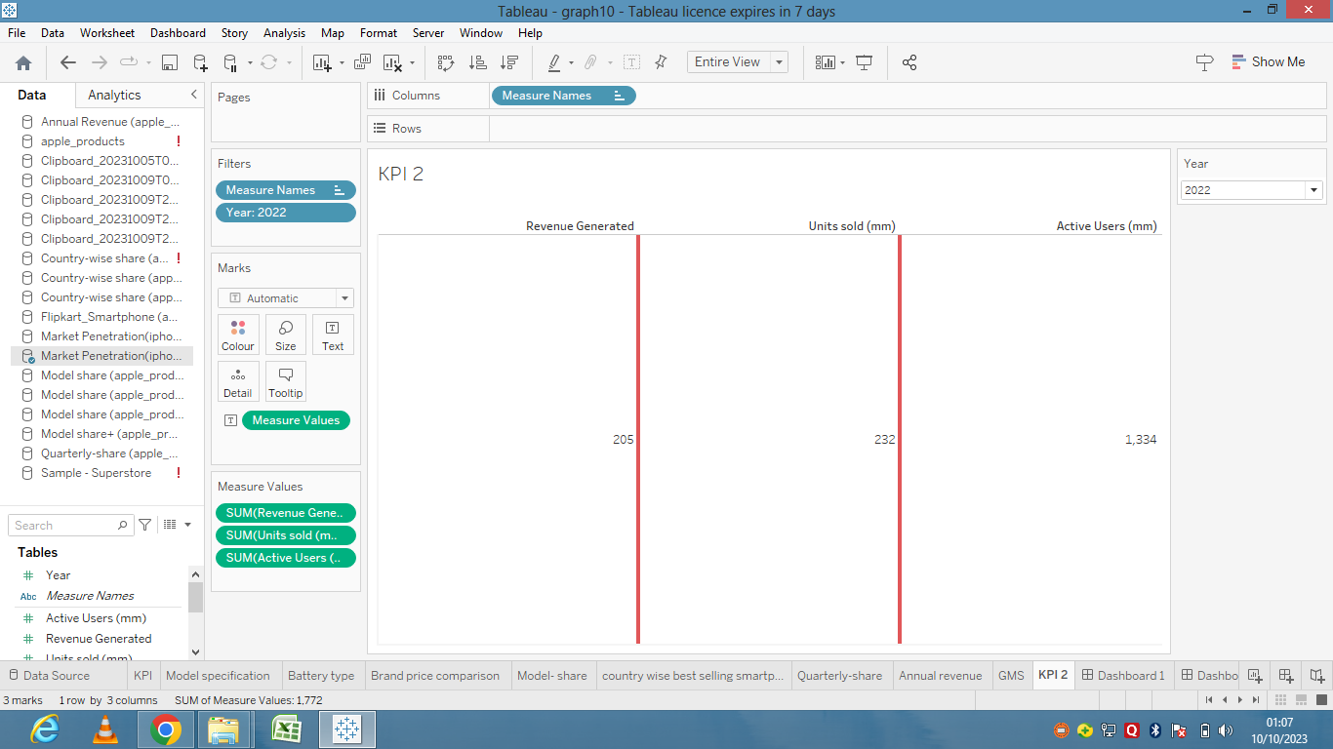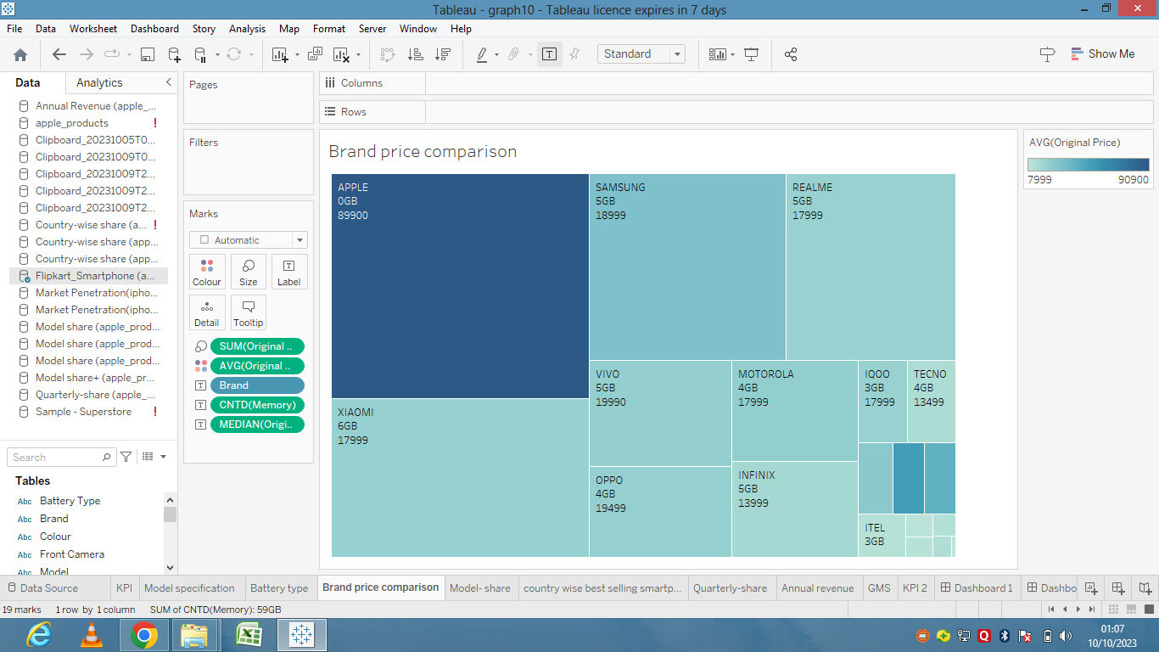

Dashboard Screenshot:

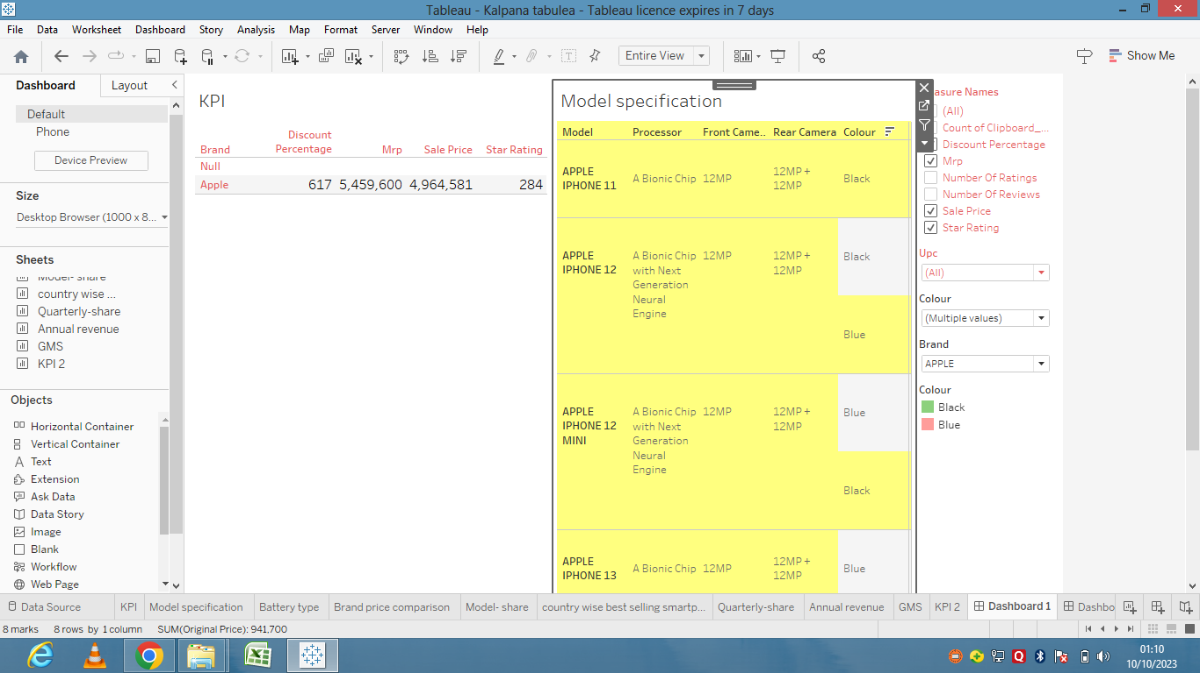

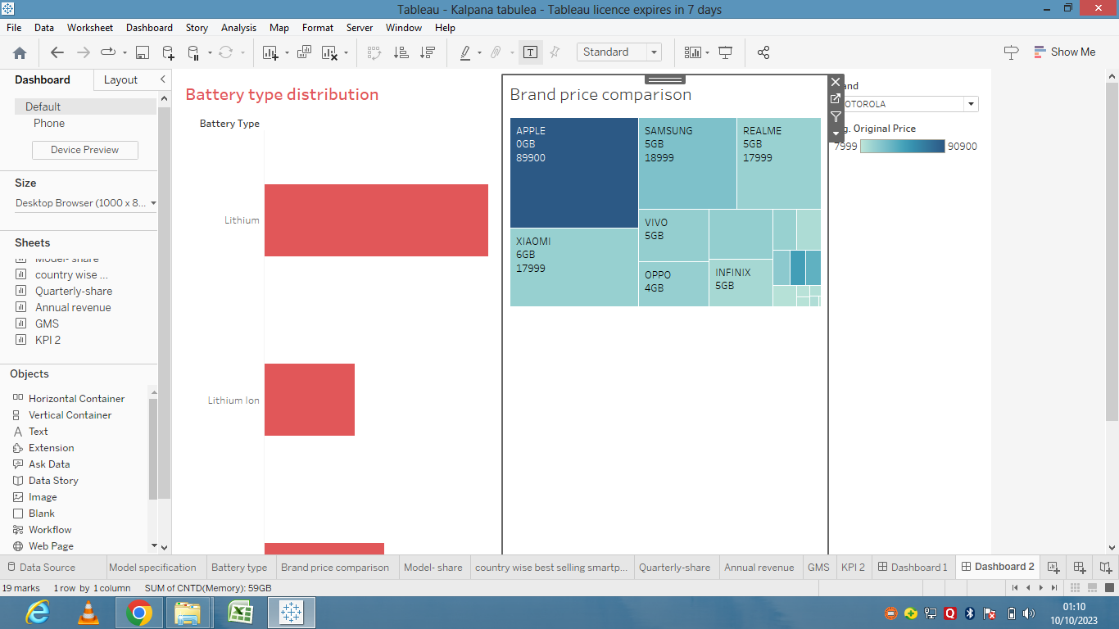

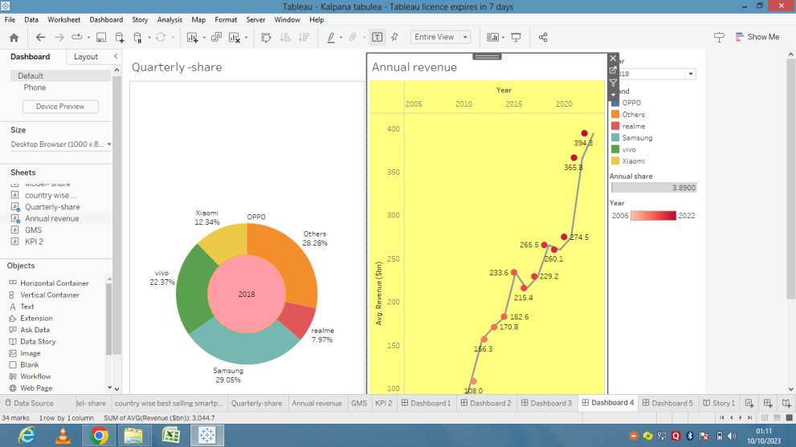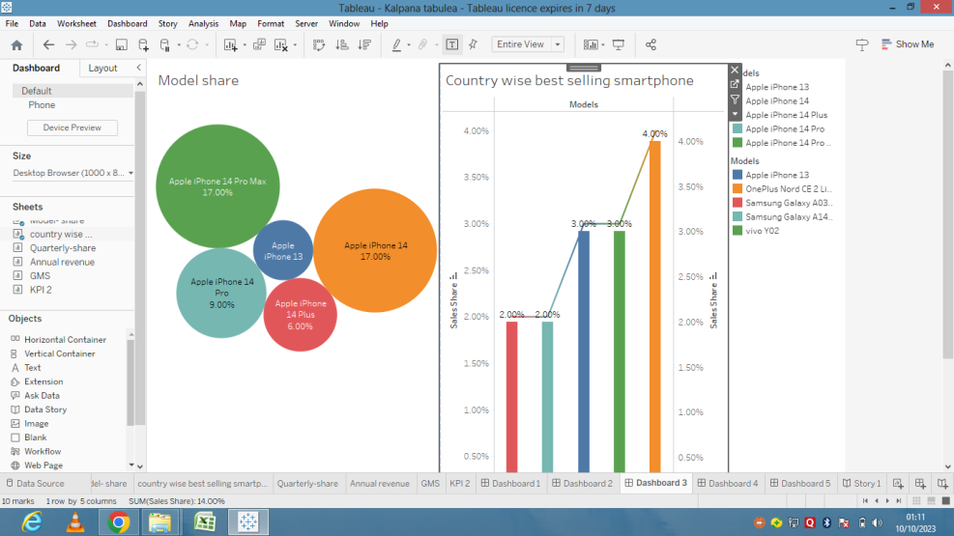

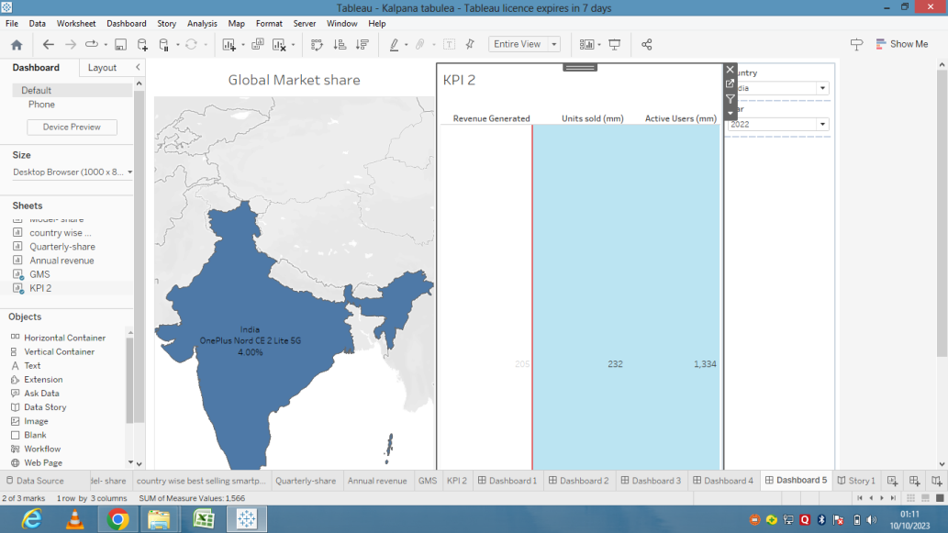

Story Screenshot:

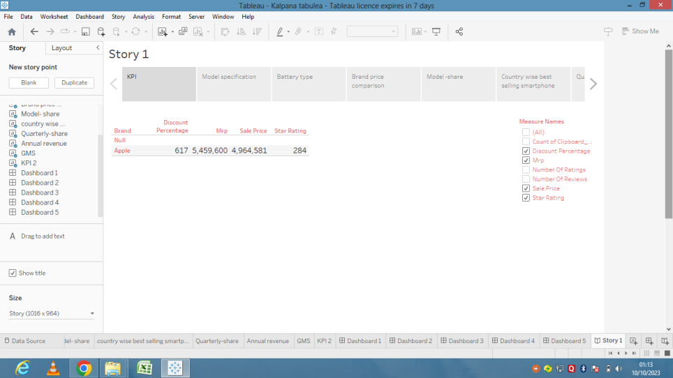

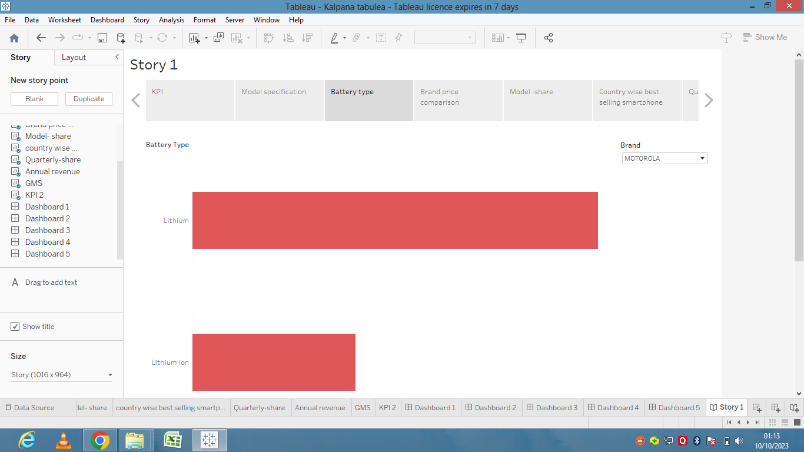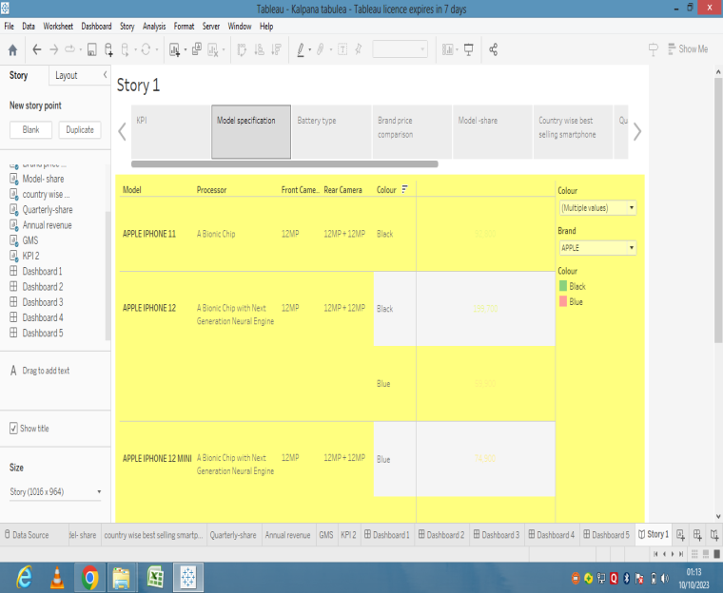

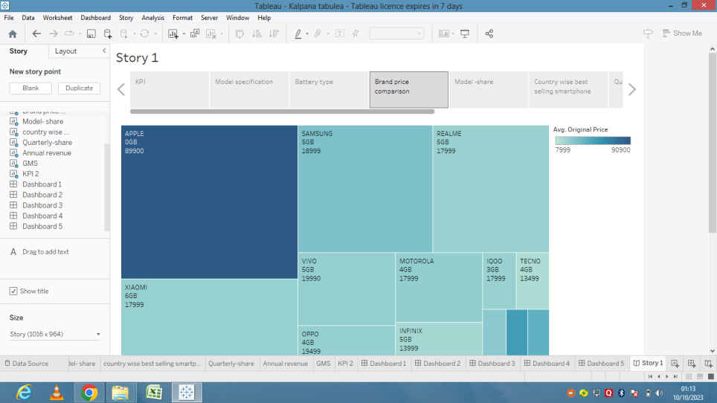

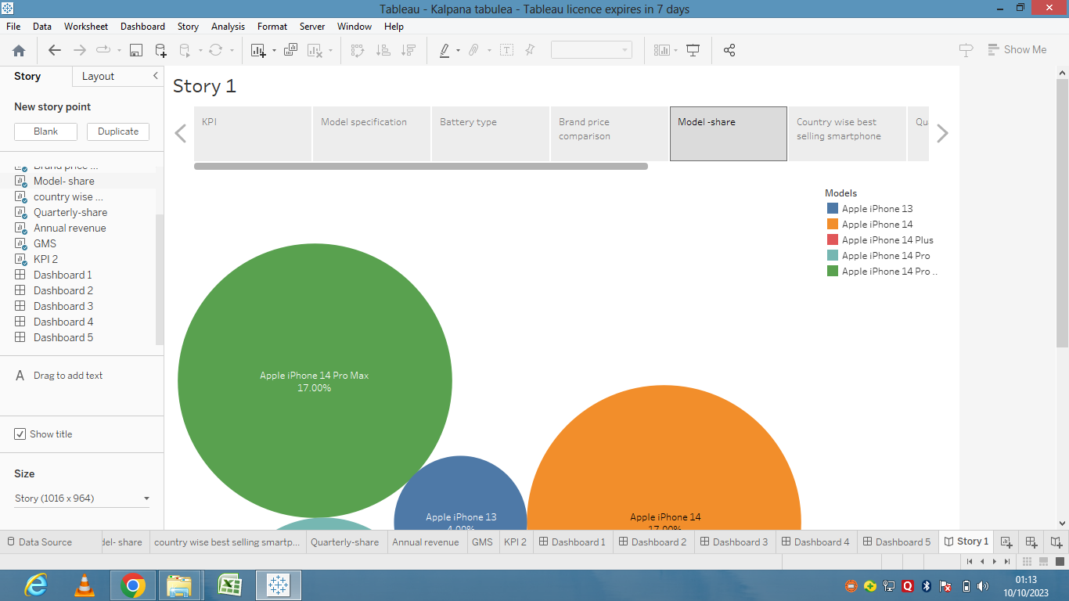

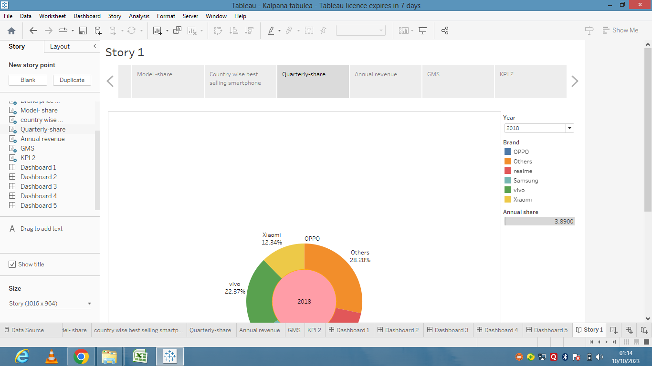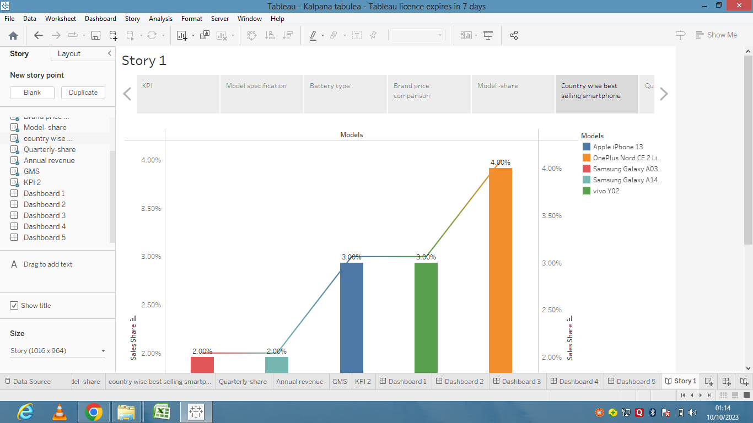

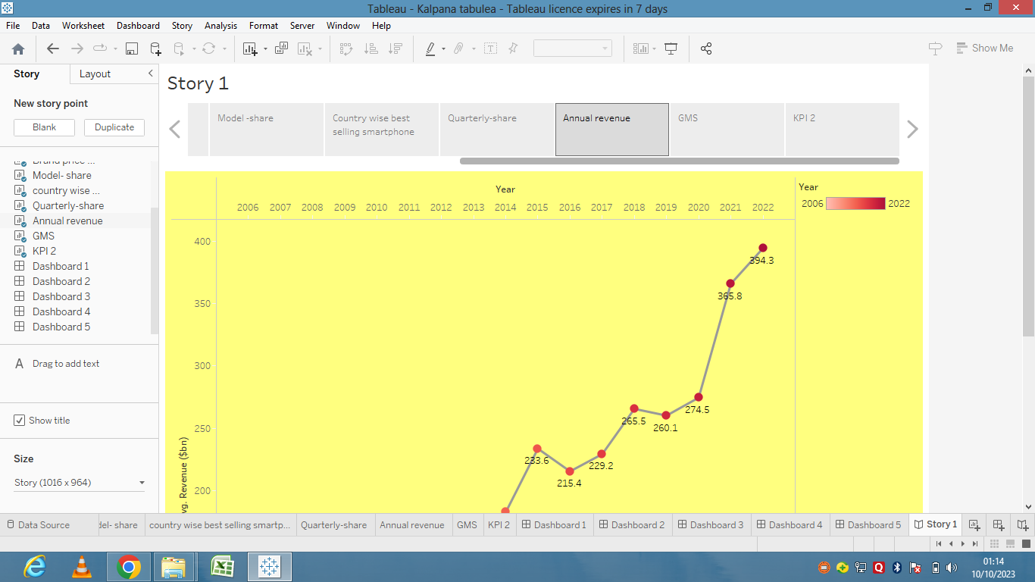

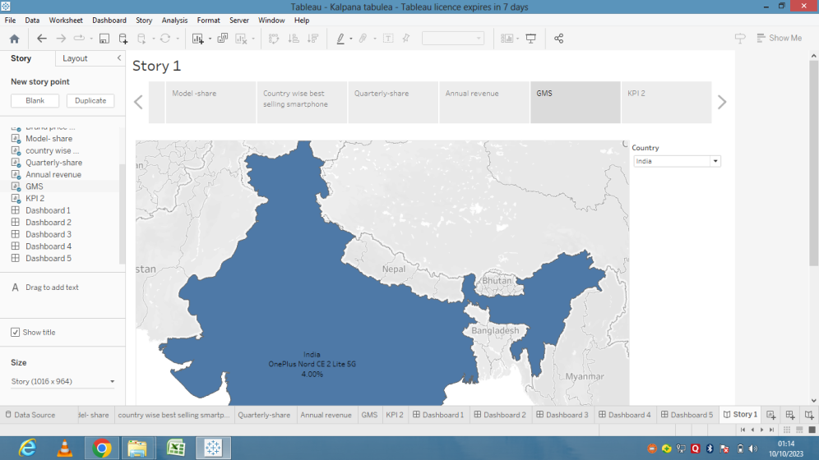

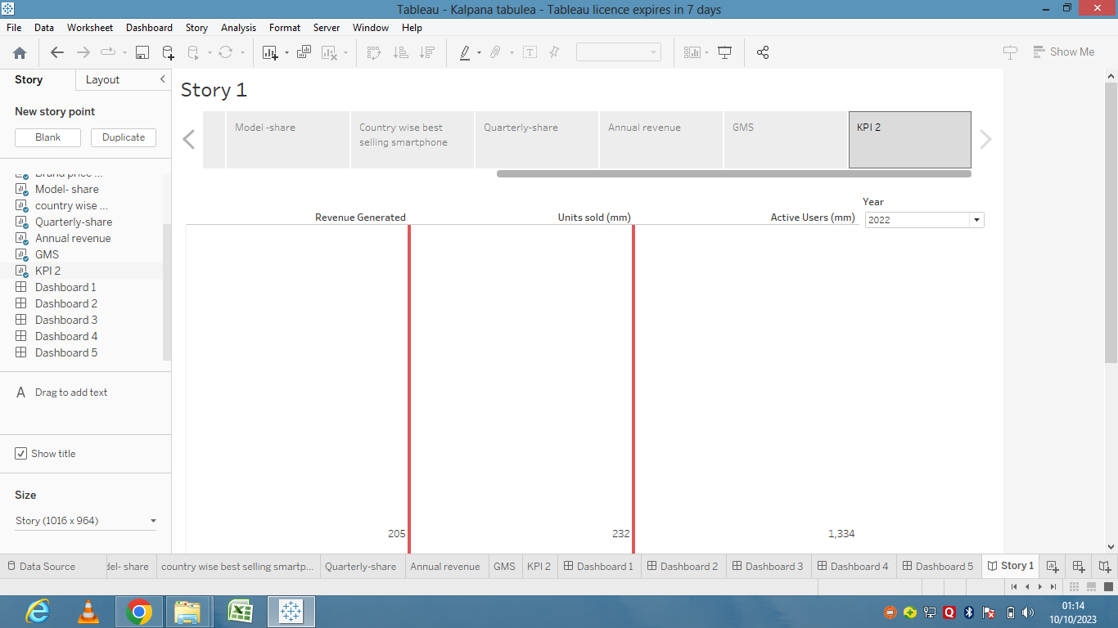

Advantages:

1. Good camera quality and zoom view.
2. Many featurers, quality and updates.
3. It has third party security.
4. It is easy to handle.
5. It has no bloat ware

Disadvangtages:

1. High cost
2. Non Removable battery
3. Limited customization
4. Frailty
5. No expandable storage

Conclusion:

Apple and the iphone is a great corporation making what the consumer wants in a global market. It is a apparent that the iphone was, and still, a remarkable invention of technological advancement.

Applications:

1. The apple ecosystem
2. Ease of use
3. Apple pay
4. Iphones hold their value
5. Family sharing

Future scopes:

The next decade, the apple could evolve into a hub for smart glasses and other devices. The iphones core elements,like its display and charing systems are also expected to get a significant boast.ssss